Emanuel A. LoPresto Memorial
Inter-Club Photography Competition

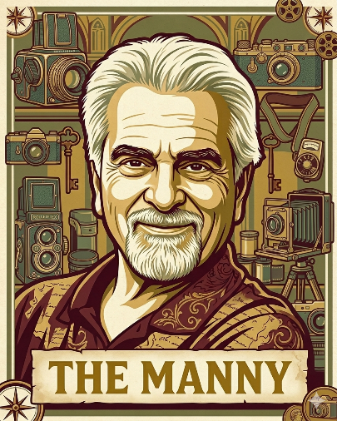
Purpose
The Emanuel A. LoPresto Memorial Inter-Club Photography Competition, established in 2026, honors the legacy of Emanuel A. LoPresto by fostering friendship, encouraging artistic exchange, and celebrating photographic excellence between the Science Museum Camera Club and the South Towns Photography Club.

Date: April 1, 2027
Location: South Towns Photography Club
Hamburg Community Center, 107 Prospect Ave, Hamburg, NY

Abbreviated Rules:
- Image Category: Open Digital Image
- Eligibility:
  - Eligible images must have been entered into the photographer's club competition during the preceding calendar year. For example, images entered in club competition between January 1, 2026, and December 31, 2026, are eligible for the April 2027 competition.
  - Both digital images and photographs previously entered as prints are eligible. Prints must be converted to a digital image by the photographer for submission to this competition.
- Image Selection: Each club's selection committee shall choose images with the goal of maximizing member participation and spreading the entries across all club competitors. The committee shall first select one image from each eligible competitor and then continue selecting additional images, one per competitor, in successive rounds until a total of 60 images have been selected.
- Judging: Two judges from outside the participating clubs shall be secured for the competition.
- Scoring Format:
  - Each judge shall score every image on a scale of 1 to 9.
  - The scores from both judges shall be combined to produce a total score for each image.
- To determine the winning club, the total scores of all images submitted by each club shall be added together.
  - The club with the highest cumulative score shall be declared the winner.
  - In the event of a tie, the club with the greater number of images receiving a combined score of 18 shall be declared the winner.
- Awards: the judges will select the top the overall winners and provide commentary during the selection process. Ribbons will be awarded to the photographers of the First, Second, and Third Place winners.
May the Best Club Win

